Test Case: tc002_SPX_Dev5_Crear_Requisicion_Spot_Con_FAD_Tipo_Cobro_CC
Step 1 - Enter username and password and click to button Enter : Credentials Entered
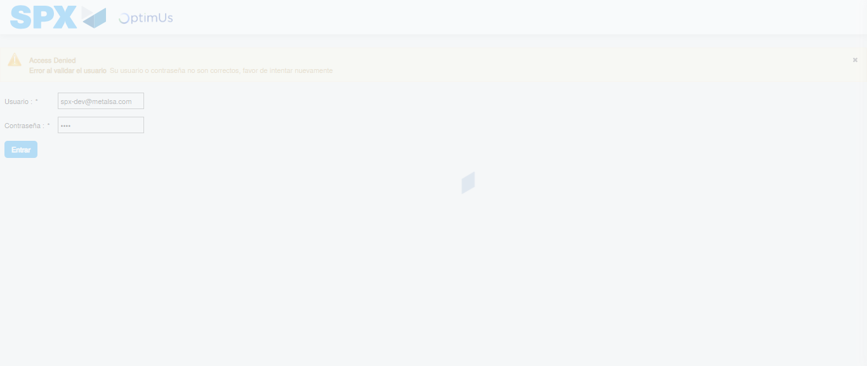Image file-name: QC_Testing-tc002_SPX_Dev5_Crear_Requisicion_Spot_Con_FAD_Tipo_Cobro_CC-1790178557819

Step 2 - Select to UEN and Access to Spot Buy Requisitions : UEN Correctly selected and Correct access
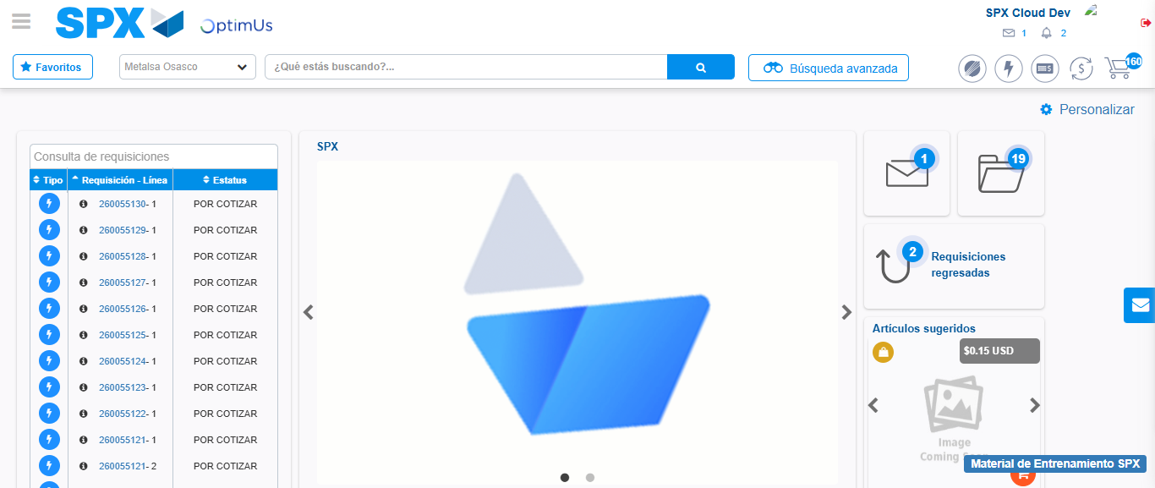Image file-name: QC_Testing-tc002_SPX_Dev5_Crear_Requisicion_Spot_Con_FAD_Tipo_Cobro_CC-1790178581631

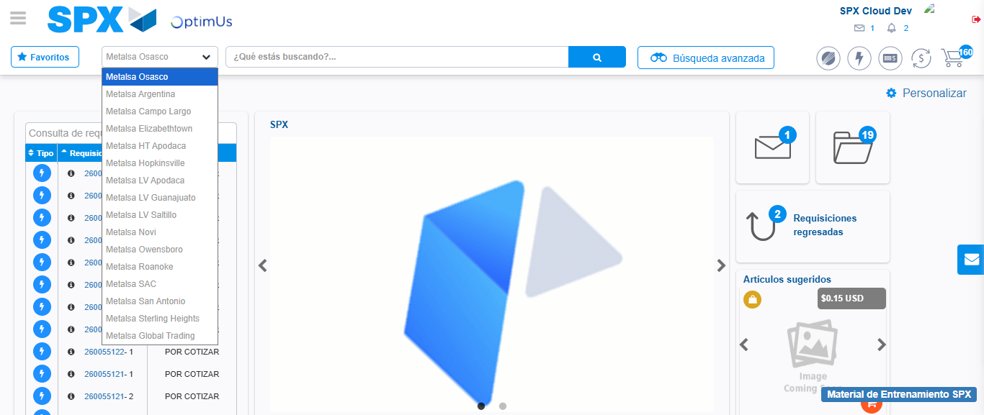Image file-name: QC_Testing-tc002_SPX_Dev5_Crear_Requisicion_Spot_Con_FAD_Tipo_Cobro_CC-1790178582226

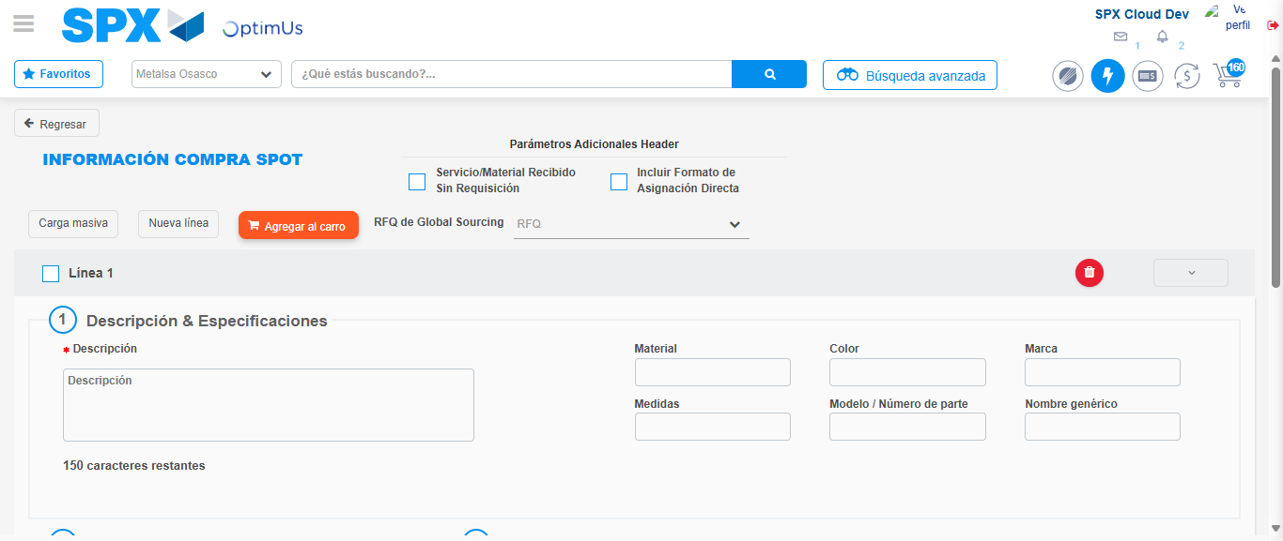Image file-name: QC_Testing-tc002_SPX_Dev5_Crear_Requisicion_Spot_Con_FAD_Tipo_Cobro_CC-1790178592221

Step 3 - Add FAD to Requisition: FAD Successfully Added
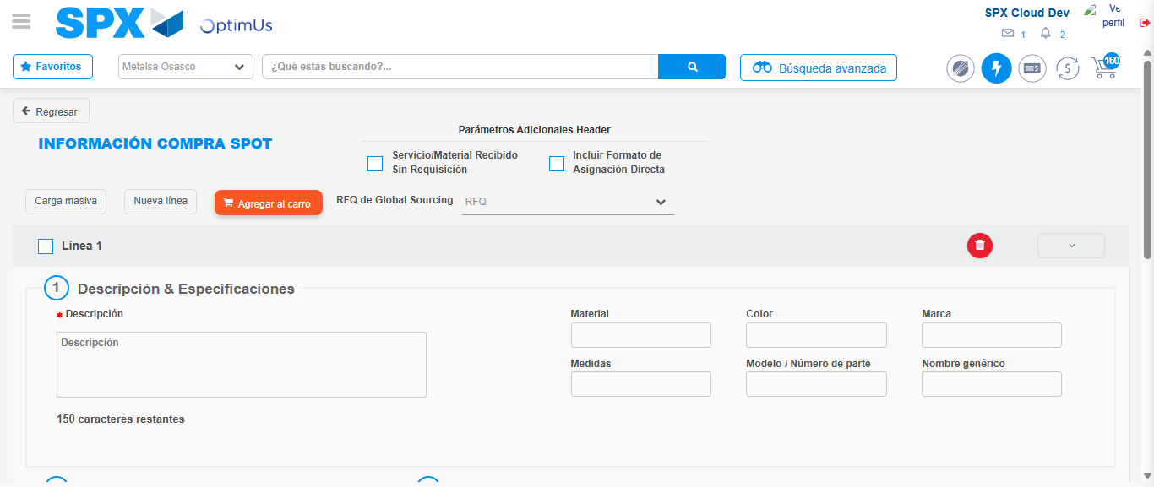Image file-name: QC_Testing-tc002_SPX_Dev5_Crear_Requisicion_Spot_Con_FAD_Tipo_Cobro_CC-1790178592523

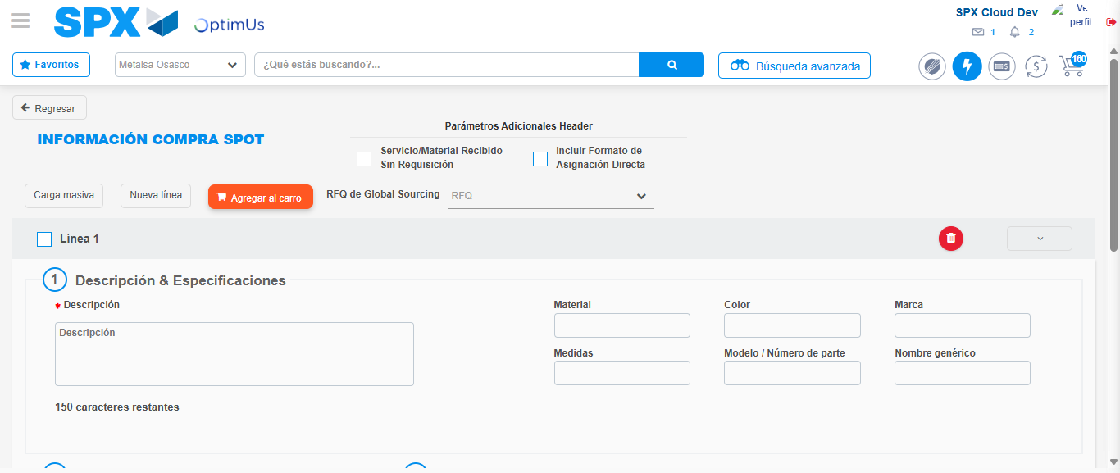Image file-name: QC_Testing-tc002_SPX_Dev5_Crear_Requisicion_Spot_Con_FAD_Tipo_Cobro_CC-1790178592754

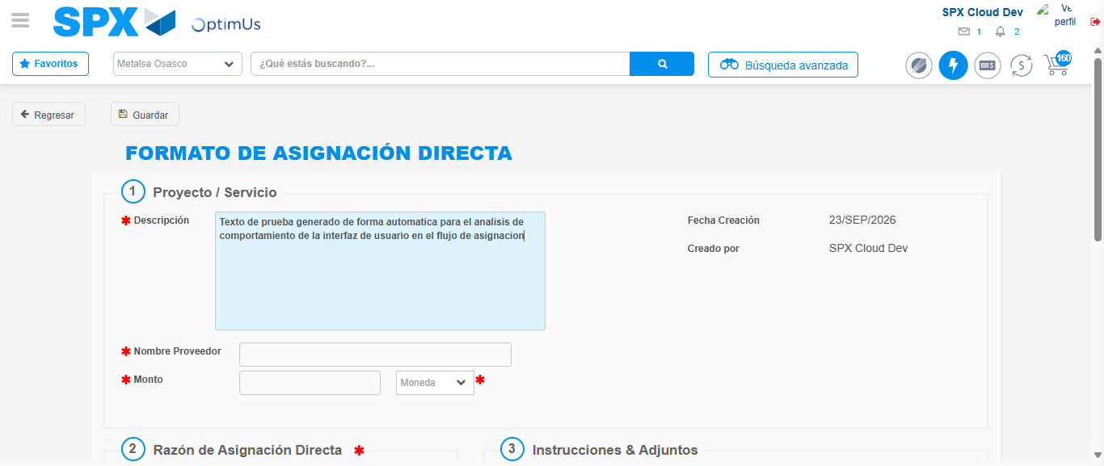Image file-name: QC_Testing-tc002_SPX_Dev5_Crear_Requisicion_Spot_Con_FAD_Tipo_Cobro_CC-1790178595493

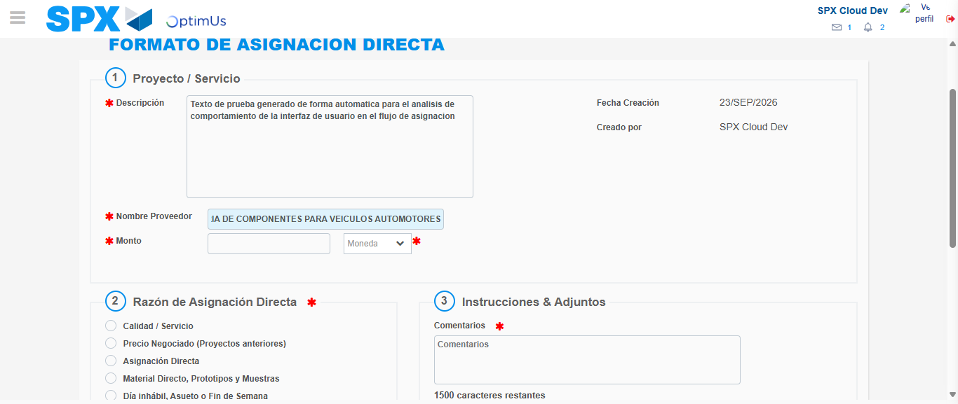Image file-name: QC_Testing-tc002_SPX_Dev5_Crear_Requisicion_Spot_Con_FAD_Tipo_Cobro_CC-1790178603924

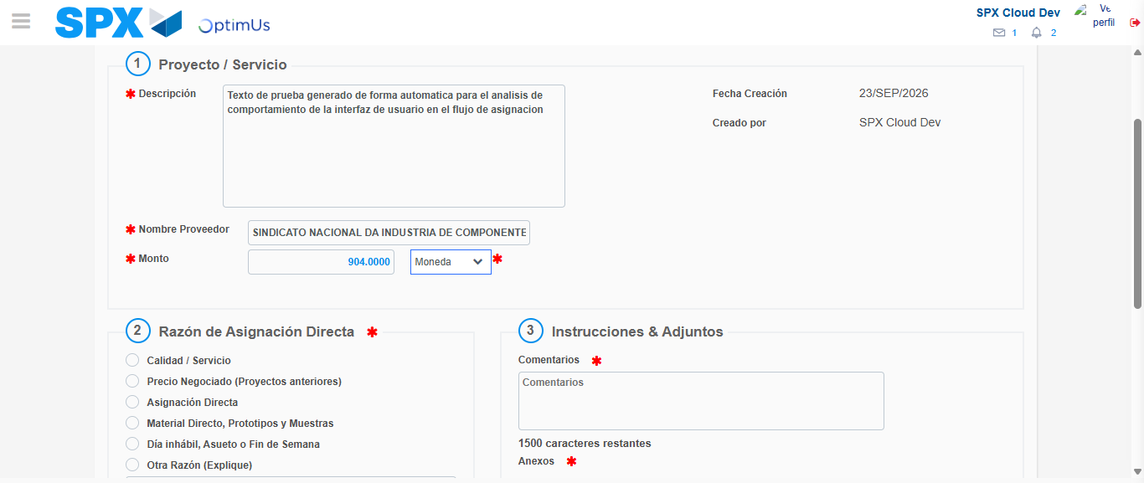Image file-name: QC_Testing-tc002_SPX_Dev5_Crear_Requisicion_Spot_Con_FAD_Tipo_Cobro_CC-1790178604317

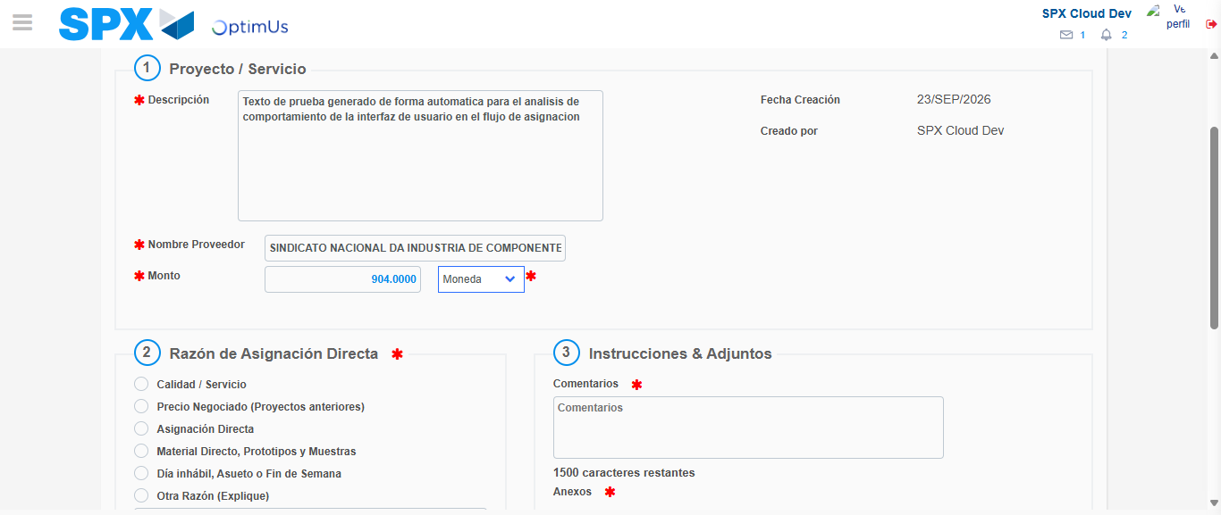Image file-name: QC_Testing-tc002_SPX_Dev5_Crear_Requisicion_Spot_Con_FAD_Tipo_Cobro_CC-1790178604540

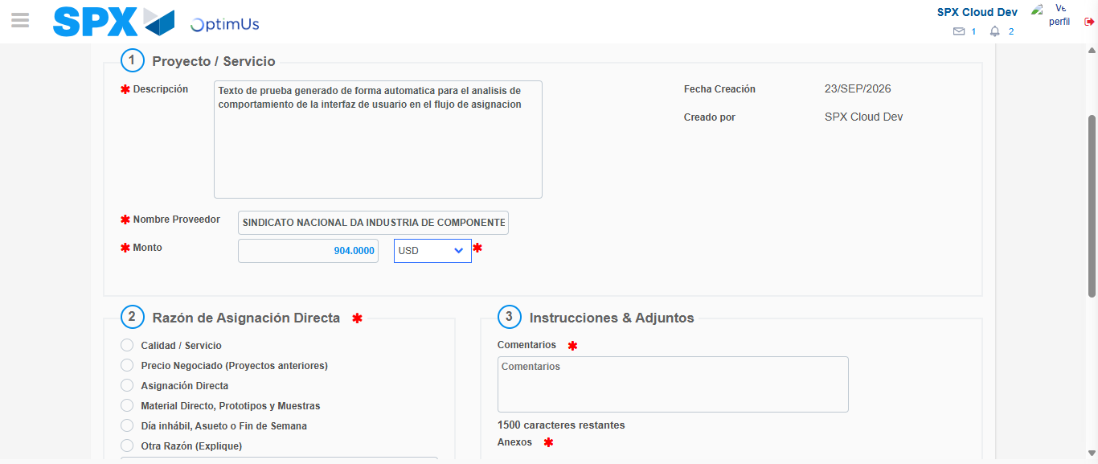Image file-name: QC_Testing-tc002_SPX_Dev5_Crear_Requisicion_Spot_Con_FAD_Tipo_Cobro_CC-1790178604872

Image file-name: QC_Testing-tc002_SPX_Dev5_Crear_Requisicion_Spot_Con_FAD_Tipo_Cobro_CC-1790178605056

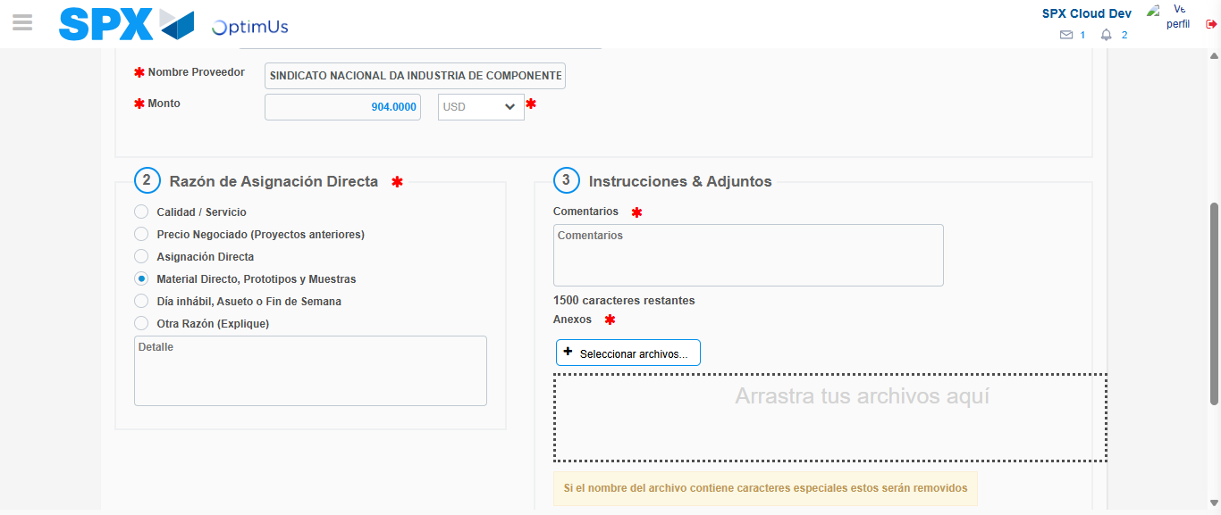Image file-name: QC_Testing-tc002_SPX_Dev5_Crear_Requisicion_Spot_Con_FAD_Tipo_Cobro_CC-1790178605890

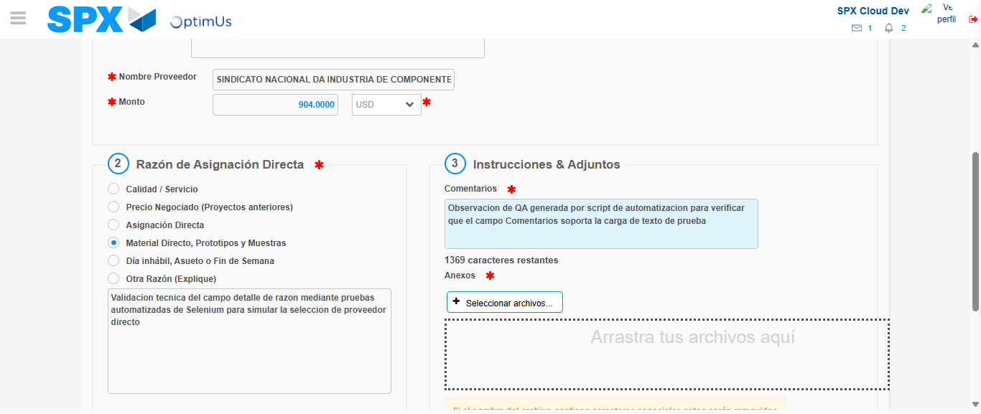Image file-name: QC_Testing-tc002_SPX_Dev5_Crear_Requisicion_Spot_Con_FAD_Tipo_Cobro_CC-1790178616837

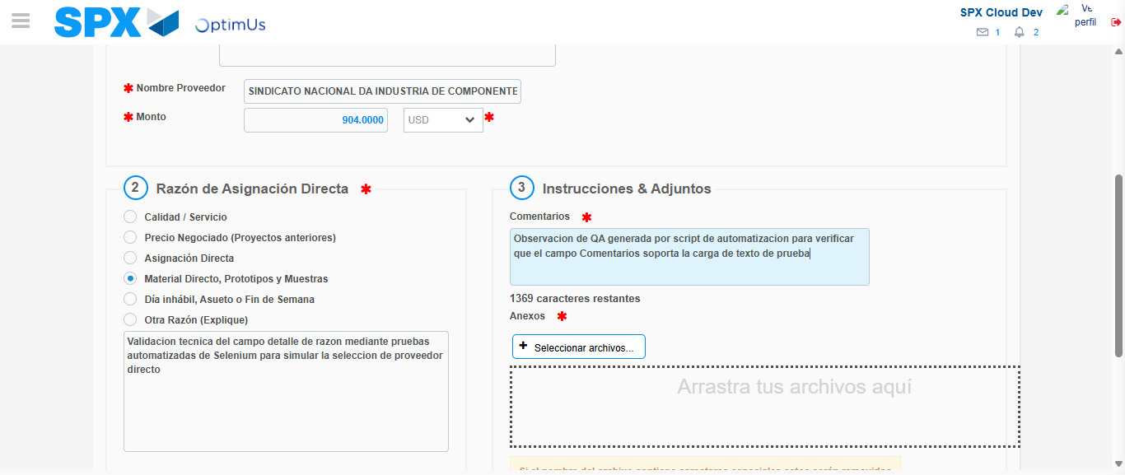Image file-name: QC_Testing-tc002_SPX_Dev5_Crear_Requisicion_Spot_Con_FAD_Tipo_Cobro_CC-1790178617440

Step 4 - Data Capture Spot Buy Requisition: Data captured correctly
Image file-name: QC_Testing-tc002_SPX_Dev5_Crear_Requisicion_Spot_Con_FAD_Tipo_Cobro_CC-1790178592523

Image file-name: QC_Testing-tc002_SPX_Dev5_Crear_Requisicion_Spot_Con_FAD_Tipo_Cobro_CC-1790178592754

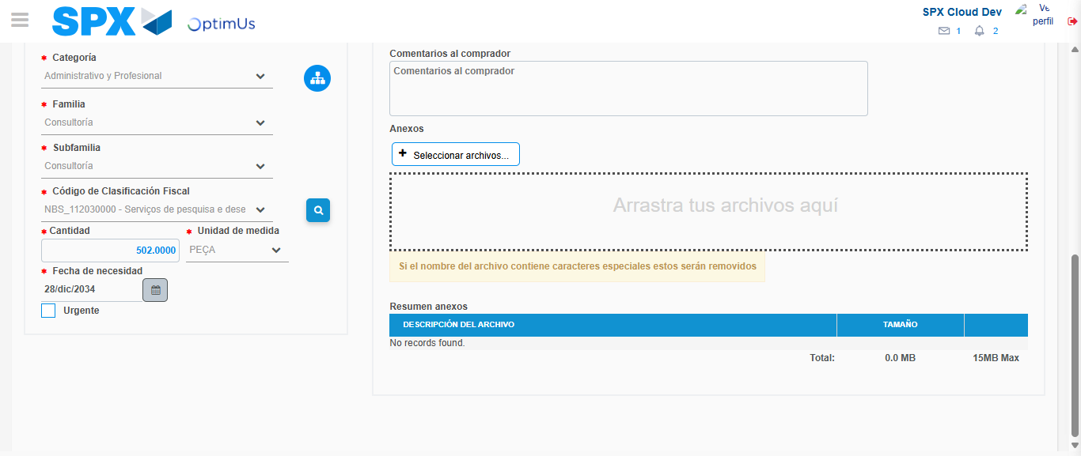Image file-name: QC_Testing-tc002_SPX_Dev5_Crear_Requisicion_Spot_Con_FAD_Tipo_Cobro_CC-1790178635221

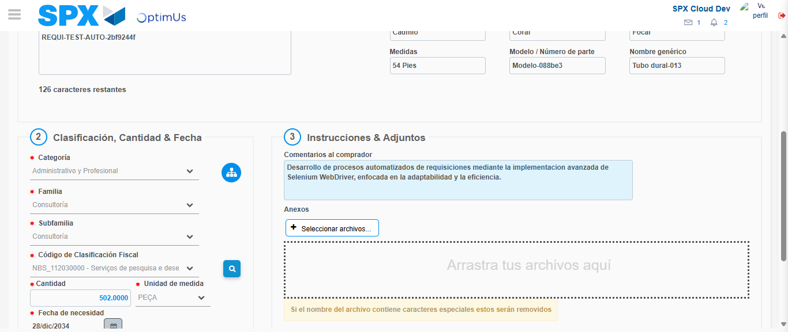Image file-name: QC_Testing-tc002_SPX_Dev5_Crear_Requisicion_Spot_Con_FAD_Tipo_Cobro_CC-1790178646000

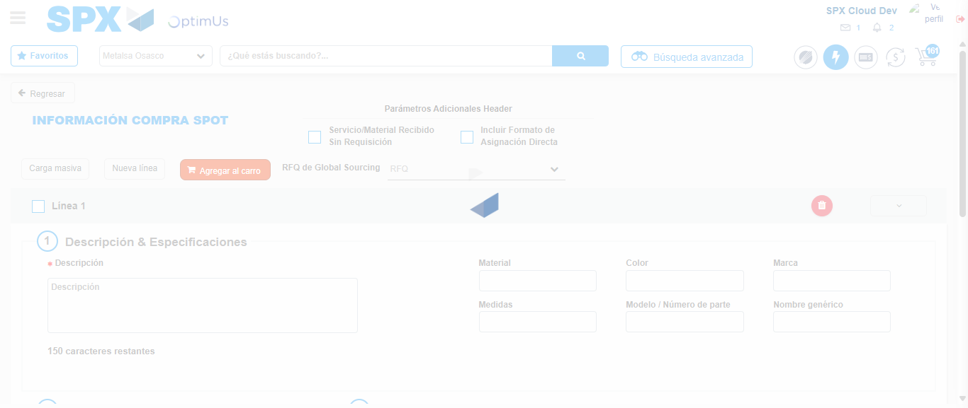Image file-name: QC_Testing-tc002_SPX_Dev5_Crear_Requisicion_Spot_Con_FAD_Tipo_Cobro_CC-1790178657756

Step 8 - Return to Main Page SPX : Return to Main Page SPX
Image file-name: QC_Testing-tc002_SPX_Dev5_Crear_Requisicion_Spot_Con_FAD_Tipo_Cobro_CC-1790178581631

Image file-name: QC_Testing-tc002_SPX_Dev5_Crear_Requisicion_Spot_Con_FAD_Tipo_Cobro_CC-1790178582226

Image file-name: QC_Testing-tc002_SPX_Dev5_Crear_Requisicion_Spot_Con_FAD_Tipo_Cobro_CC-1790178592221

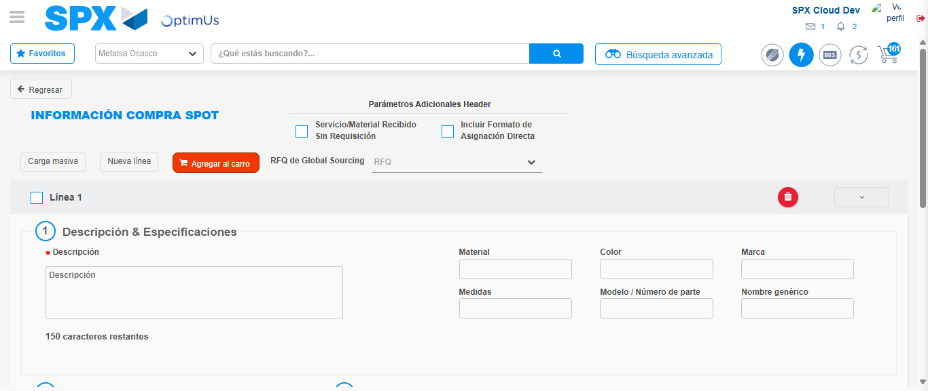Image file-name: QC_Testing-tc002_SPX_Dev5_Crear_Requisicion_Spot_Con_FAD_Tipo_Cobro_CC-1790178659938

Image file-name: QC_Testing-tc002_SPX_Dev5_Crear_Requisicion_Spot_Con_FAD_Tipo_Cobro_CC-1790178660105

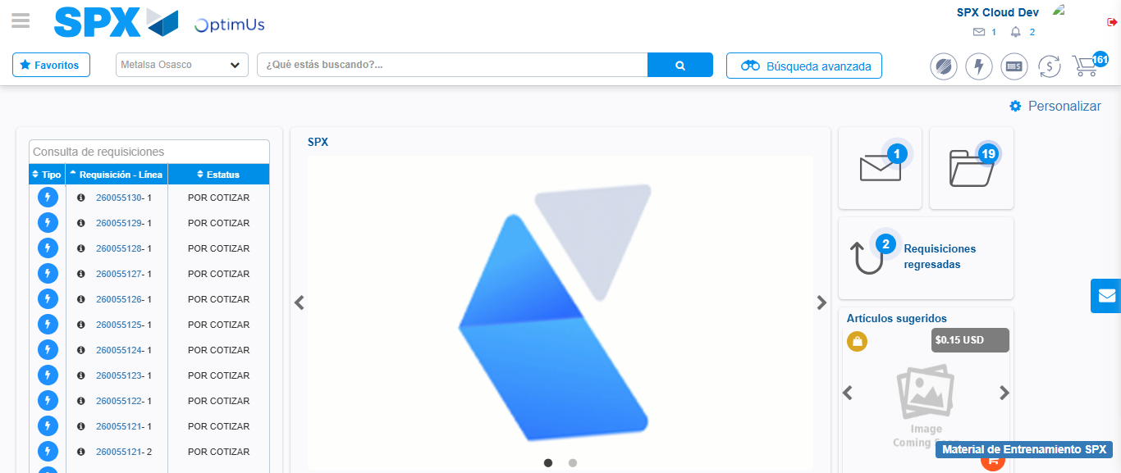Image file-name: QC_Testing-tc002_SPX_Dev5_Crear_Requisicion_Spot_Con_FAD_Tipo_Cobro_CC-1790178681272

Step 9 - Log Out : Log Out SPX
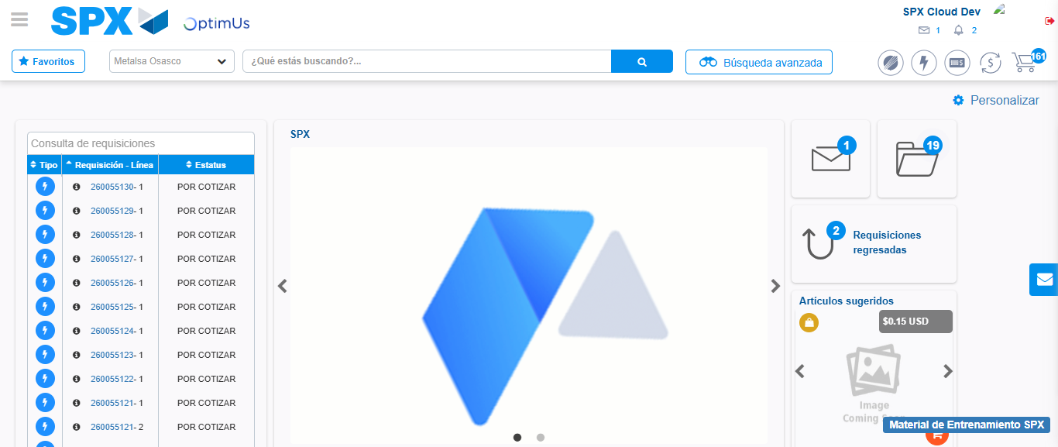Image file-name: QC_Testing-tc002_SPX_Dev5_Crear_Requisicion_Spot_Con_FAD_Tipo_Cobro_CC-1790178681596

